|  |  |
| --- | --- |
| \\VFILERDPI\DPI-Home\OBRIENR2\My Documents\Downloads\PP logo.jpg | Moree Plains Shire Council Logo |
| **COUNCIL ASSESSMENT REPORT**  NORTHERN REGIONAL PLANNING PANEL | |

|  |  |
| --- | --- |
| PANEL REFERENCE & DA NUMBER | PPSNTH -194 – Moree - DA2023/6 |
| PROPOSAL | Proposed electricity generating works - construction of a 4.99MW solar farm and associated plant, fencing and landscaping. |
| ADDRESS | Lot 2 DP 773238 No. 1957 Carnarvon Highway, Ashley  and Lot 3 DP 773238 No. 2761 Carnarvon Highway, Ashley  (also known as 338 Windmill Road, Garah) |
| APPLICANT | OGP Group, trading as The Trustee for Oil Gas Power International Services Unit Trust |
| OWNER | AFF Land Pty Limited as Trustee for AFF Land Trust |
| DA LODGEMENT DATE | 2 January 2023 |
| APPLICATION TYPE | Development Application |
| REGIONALLY SIGNIFICANT CRITERIA | Section 2.19(1) and Clause 5 of Schedule 6 of State Environmental Planning Policy (Planning Systems) 2021 declares the proposal regionally significant development as: The proposed Solar Farm is private infrastructure (electricity generating works) with a CIV of over $5 million. |
| CIV | $7,081,815.00 (excluding GST) |
| CLAUSE 4.6 REQUESTS | N/A |
| KEY SEPP/LEP | * Environmental Protection and Biodiversity Conservation Act 1999 and Regulations 2000; * Biodiversity Conservation Act 2016; * National Parks & Wildlife Act 1974; * Contaminated Land Management Act 1997; * Heritage Act 1977; * State Environmental Planning Policy (Resilience and Hazards) 2021; * State Environmental Planning Policy (Biodiversity & Conservation) 2021; * State Environmental Planning Policy (Transport and Infrastructure) 2021; * State Environmental Planning Policy (Planning Systems) 2021; * State Environmental Planning Policy (Primary Production) 2021; * Moree Plains Local Environmental Plan 2011; * Moree Plains Development Control Plan 2013. |
| TOTAL & UNIQUE SUBMISSIONS  KEY ISSUES IN SUBMISSIONS | None received  N/A |
| DOCUMENTS SUBMITTED FOR CONSIDERATION | * Design Drawings prepared by OGP Group; * Landscape Drawing prepared by RPS Group Pty Ltd; * Civil Engineering Drawings prepared by Northrop Consulting Engineers Pty Ltd; * Statement of Environment Effects 22 December 2023 (as amended 17 April 2023) and prepared by RPS APP Consulting Pty Ltd; * ‘SEPP Resilience and Hazards Assessment’ report prepared by Advitech Pty Limited dated 16 December 2022, and, in particular, its recommendation for a Preliminary Hazard Analysis (PHA) to be undertaken prior to the installation of any Redox flow batteries; * ‘Surface Water Assessment Report’ prepared by Northrop Consulting Engineers Pty Ltd, dated 16 December 2022, Revision A. |
| SPECIAL INFRASTRUCTURE CONTRIBUTIONS (S7.24) | N/A |
| RECOMMENDATION | Approval |
| DRAFT CONDITIONS TO APPLICANT | Attachment 1 |
| SCHEDULED MEETING DATE | 11 July 2023 |
| PLAN VERSION | * Design Drawings – 7/12/22; * Landscape Drawings - 22/12/2022; * Civil Engineering Drawings - 13/12/2022. |
| PREPARED BY | John McFadden, Consultant Planner |
| DATE OF REPORT | 3 July 2023 |

**EXECUTIVE SUMMARY**

**The Proposal**

The development involves the Construction/installation of a solar farm (‘Electricity Generating Works) comprising:-

* A solar photovoltaic (PV) electricity generating facility including 2.38m x 1.3m solar panels with ancillary electricity generation infrastructure including inverters, a Battery Energy Storage System (BESS) and an onsite substation of 4.99MW to be connected to the state electricity grid;
* The battery storage system may use either Redox-Flow type batteries, or the more compact Lithium Ion type system;
* Construction of an unsealed gravel access road to the solar farm site from an existing unsealed access road between the Midkin Gin and Carnarvon Highway;
* Erection of a chain link 2.4m security fence around the perimeter of the site;
* Construction of a 42m x 42m temporary construction compound with crib room, offices, toilets 40 foot containers and water tanks, close to the Midkin Gin on Lot 2 DP 773238;
* Construction of three hardstand areas to the north of the solar panel arrays - one containing a 6m x 8m storage maintenance shed, the other containing the BESS banks, DC/DC converter, Central Inverter plant and the third, plant for the on-site substation;
* Construction of internal roads;
* Ancillary development including stormwater infrastructure;
* Provision on the site for a stage 2 expansion with an addition of a second BESS system and potential expansion of the solar farm up to approximately 11,500 solar panels;
* Landscape planting along the Carnarvon Highway frontage to the north east of the site and along the access road to the Midkin Gin to aid the visual screening of the development.

**Permissibility**

The development proposal for ‘electricity generating works’ is defined under s.1.4 of *Moree Plains Local Environmental Plan 2011* (LEP) and is neither listed under schedule 3 as ‘Permitted with consent’, nor listed in schedule 4 – as ‘Prohibited’.

The use is therefore included as ‘Any other development not specified in item 2 or 4’ which is found at the end of the list of uses in Schedule 3 – ‘Permitted with consent’ pursuant to the LEP Land Use Table. Accordingly, the proposal is permitted with consent in the RU1 Primary Production zone under the LEP.

In addition to the above, clause 2.36(9) of *State Environmental Planning Policy Transport and Infrastructure) 2021* (SEPP Transport and Infrastructure) states that ‘development for the purpose of a solar energy system may be carried out by any person with consent on any land.’

**The Site**

The site has an area of 14.5ha and is a generally rectangular section of the larger irregular shaped Lot 3 DP 773238 which has a total area of 376.4ha. The portion of the lot which is to be used for the purposes of the solar farm is in the northern section of Lot 3, with the private access road to Midkin Gin to the north, and Carnarvon Highway to the east.

**History**

The land on which the solar farm is to be located has no previous development history with its current use being cropping land, however, the Midkin Cotton Gin is located to the west and will be the principal user of the solar farm’s output.

**Key Issues**

The key issues for the development are:-

• Managing the hazard of fire associated with the BESS system;

• Ensuring the development is decommissioned in a safe fashion at its ‘end of life’ to prevent contamination by chemicals from the Bess system;

• Ensuring no traffic impacts arise as a result of the construction phases of the development;

• Ensuring adequate landscape screening of the development is undertaken and that nearby Koala feed trees are preserved.

**Key concerns from agencies**

**Rural Fire Service**

* Bushfire hazard mitigation;
* Mitigation of fire hazard from battery system failure.

**Essential Energy**

* The main solar farm is clear of Essential Energy's existing infrastructure.
* The temporary offices and hardstand area must be clear of the powerline by 10.0 metres.
* Any roadways going under the powerline must make sure the powerline meets the

required clearances for a trafficable area.

* The developer must meet SafeWork clearance requirements when working near

Powerlines.

**Transport for NSW**

* Consideration being given to the development of a Traffic Management Plan (TMP) and Code of Conduct, to provide traffic mitigation measures to address the cumulative traffic impacts, during the peak of the construction of the development and the cotton ginning season for the existing Midkin Cotton Gin.

**How the issues identified have been resolved**

**Fire**

Fire hazards from bushfires and failures in the Battery Storage system can be dealt with by conditions provided by the RFS. These principally involve maintaining an Asset Protection Zone (APZ) and provision of a 20,000ltr water tank on site.

**Decommissioning/contamination control**

A standard solar farm condition can be imposed requiring the removal of all infrastructure at the ‘end of life’ of the facility. This condition will be associated with a s.88B Positive Covenant for registration on the title of Lots 2 and 3 DP 773238.

**Traffic**

A TMP and Code of Conduct can be required to ensure no traffic conflicts arise between construction vehicles, traffic to the Midkin Gin and other users of the Carnarvon Highway.

**Retention of adjacent Koala feed trees**

A condition could be imposed requiring adjacent trees to be preserved during the construction and operational phases of the development.

**Essential Energy infrastructure and safety concerns**

The inclusion of Essential Energy’s recommended conditions would mitigate possible damage to infrastructure and enhance worker safety.

**The Public Interest**

The provision of a solar farm will not only benefit the Midkin Cotton Gin and broader community by reducing energy reliance on the state grid (which relies on fossil fuel for power generation), but, will actively contribute excess capacity to the grid which is not required by the Cotton Gin. This is beneficial to lowering greenhouse emissions and achieving sustainability targets.

**Summary of s4.15(1) matters**

Environmental Planning Instruments

The proposal is consistent with the State Environmental Planning Policies relevant to the current proposal and the Moree Plains LEP 2011.

Development Control Plans

The proposal complies with the provisions of the Moree Plains DCP 2013, subject to any required conditions of consent.

Impacts of the Development

*Natural Environment*

The proposal for a solar farm is located on cleared land previously cultivated for crops and will not involve significant disturbance of the ground. Approximately 750 trees and shrubs are to be planted along the eastern and northern perimeter to visually screen the solar farm from the Carnarvon Highway.

The Northrop Surface Water Assessment Report provided by the applicant indicates little impact on water quality and with the site being located outside Koala habitat zones the proposal will result in insignificant impacts in that regard. No other species of flora or fauna are expected to be impacted.

*Built Environment*

The built form of the development consists primarily of the solar panel arrays which will consist of up to 11,500 panels with individual dimensions of 2.38m x 1.3m. The panels would ordinarily appear to reach a height of up to 4.2m when tilted to 40 degrees from vertical.

The other structures on site are comprised of the 6m x 8m maintenance shed which is 2.9m in height, the BESS which will be comprised of up to ten, 2m x 8m x 5.125m high Redox Flow batteries or the more compact system of two 1.7m x 9.3m x 2.6m high Lithium-ion batteries. The main plant slab will also contain 1m x 1m DC convertors and a larger central inverter of 6m x 2.4m. A third smaller slab will contain the substation plant. A 2.4m chain wire security fence will surround the solar farm.

Whilst being visible from the Carnarvon Highway, in particular before the screening vegetation can take effect, the development is unlikely to impact any other development which is some distance from the subject site.

*Social and Economic*

There will be a short-term economic benefit for the local area with the employment of up to 40 employees for the 12-16 week construction phase. However, the 1-2 maintenance subcontractors will enjoy a longer period of employment with the long-term operation of the solar farm.

**Suitability of the site for the development**

It is considered the site, being cleared agricultural land adjacent to the Midkin Gin and Essential Energy infrastructure, is suitable for the proposed development.

**Submissions**

No public submissions were receivedin response to notification of the application.

**The Public Interest**

As previously mentioned, the proposal is considered to be in the public interest.

**Recommendation**

That, pursuant to Section 4.16(1)(a) of the *EPA Act*, DA 2023/6 is recommended for approval subject to the conditions contained at **Attachment A** of this report.

1. **THE SITE AND LOCALITY**
   1. **The Site**

The site is described as Lot 2 DP 773238 No. 1957 Carnarvon Highway, Ashley and Lot 3 DP 773238 No. 2761 Carnarvon Highway, Ashley and is also known as 338 Windmill Road, Garah.

The site has an area of 14.5ha and occupies a generally rectangular section of the larger irregular shaped Lot 3 DP 773238 which has a total area of 376.4ha. The portion of the lot which is to be used for the purposes of the solar farm is in the northern section of Lot 3, with the private access road to Midkin Gin to the north, and Carnarvon Highway to the east.

The proposed access road, temporary stockpile and laydown area will be located on the adjoining lot to the north and west on Lot 2 DP 773238.

To the west of the proposed solar farm is the Midkin Gin and to the south, cultivated cropping land. At present, the land on which the solar farm is to be located is vacant cropping land most recently planted with a barley crop. The land is generally level, the survey plan indicating only a 0.2m variation of levels over the area where the solar panel arrays, BESS and other plant is to be located.

The temporary construction and laydown area is to be located approximately 250m to the northwest of the solar farm array area closer to the Midkin Gin. Two areas of native trees exist to the southwest and south-south west of the solar farm, however these areas are to be largely unaffected by the proposal.

The development is 1.5-2km distant from the Midkin Homestead, Heritage Item.

Flooding and stormwater related issues are not considered a significant constraint for the site as outlined in the ‘Surface Water Assessment Report’ prepared by Northrop Consulting Engineers Pty Ltd, dated 16 December 2022, provided with the application.

The site of the proposed solar farm (not temporary storage area to the west) is classified as Vegetation Category 3. However, the area to be utilised is cleared cropping land. Some remnant bushland exists to the southwest approximately 80-100m from the southwest corner of the solar arrays.

Grass fires would appear to be the main, natural fire constraint however this can be resolved by vegetation management of the Asset Protection Zone (APZ). The proposed Battery Energy Storage System (BESS) would appear to be the main fire hazard however the RFS has been consulted and conditions recommended to mitigate this constraint.

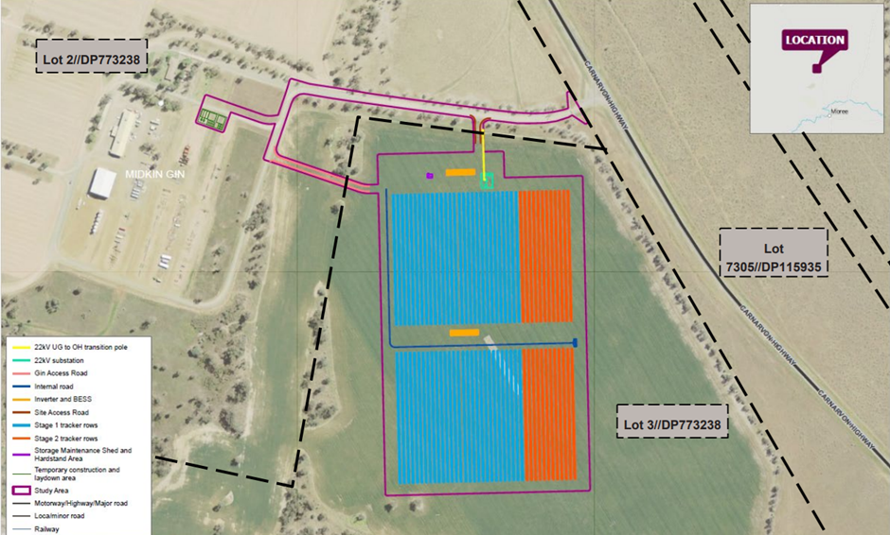

**Figure 1** – Aerial Photo of site with solar arrays, laydown areas and internal access roads in relation to the Midkin Cotton Gin (excerpt from Applicant’s SEE prepared by RPS APP 2023)

* 1. **The Locality**

The proposed development is located within the Midkin Gin site which is located in rural land zoned RU1- Primary Production, with surrounding properties used for that purpose.

Surrounding the larger Midkin Gin and proposed solar farm site to the west and northwest is cropping land, to the north east and east is the Carnarvon Highway, a travelling stock route, railway line, scrub area and cropping land beyond, whilst to the south and south east, there is vacant land and the northern outskirts of the Ashley township.

To the south of the site and across River Street is a large cultivated paddock on land zoned RU1 – Primary Production. The nearest dwellings are 1.5-2km distant from the site at the north eastern portion of the Ashley township.

No other similar (Solar Farm) developments are in the area. However approval was granted on 24 May 20233 for a solar farm approximately 1 kilometre to the east of the site being Rosedale Road ASHLEY construction of which has not commenced to date.

The proposal is located close to the Carnarvon Highway which links the regional township of Moree with Mungindi to the northwest.

The development is located approximately 2 km from the village of Ashley (Population 339 2012 Census) which in turn is located 18km from Moree.

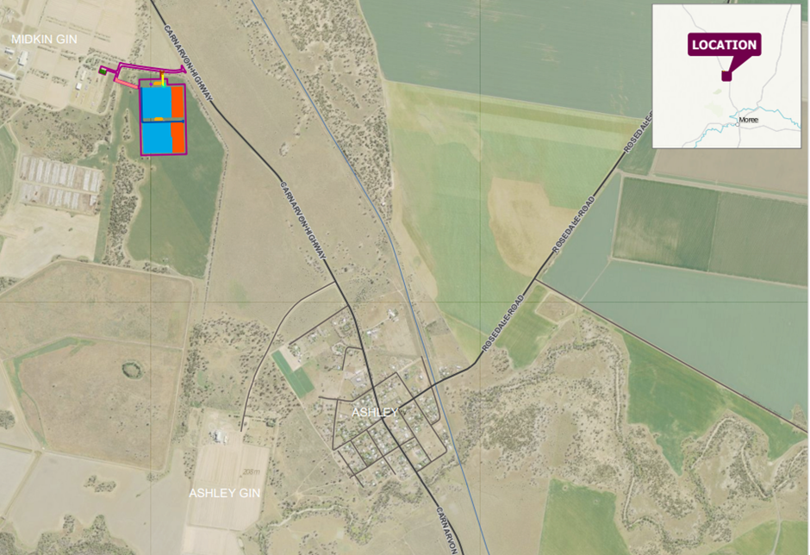

**Figure 2** - Location and Aerial Photograph of Locality (excerpt from Applicant’s SEE prepared by RPS APP 2023)

1. **THE PROPOSAL AND BACKGROUND** 
   1. **The Proposal**

The proposal seeks consent for the Construction of a 4.99MW solar farm (Electricity Generating Works), associated plant, fencing and landscaping.

Specifically, the proposal involves:

Construction/installation comprising:-

* A solar photovoltaic (PV) electricity generating facility including 2.38m x 1.3m solar panels with ancillary electricity generation infrastructure (including inverters, a Battery Energy Storage System (BESS) and an onsite substation of 4.99MW to be connected to the State Electricity grid;
* The battery storage system may use either Redox-Flow type batteries, the more compact Lithium Ion type system or a hybrid of the two types;
* Construction of an unsealed gravel access road to the solar farm site from an existing unsealed access road between the Midkin Gin and Carnarvon Highway.
* Erection of a chain link 2.4m security fence around the perimeter of the site;
* Construction of a 42m x 42m Temporary Construction compound with crib room, offices, toilets 40-foot containers and water tanks, close to the Midkin Gin on Lot 2 DP 773238.
* Construction of three hardstand areas to the north of the solar panel arrays - one containing a 6m x 8m storage maintenance shed, the other containing the BESS banks, DC/DC converter, Central Inverter plant and the third, plant for the on-site substation;
* Construction of internal roads;
* Ancillary development including stormwater infrastructure;
* Provision on the site for a stage 2 expansion with an addition of a second BESS system and potential expansion of the solar farm up to approximately 11,500 solar panels;
* Landscape planting along the Carnarvon Highway frontage to the north east of the site and along the access road to the Midkin Gin to aid the visual screening of the development. Two trees are located close to the south west corner of the solar panel arrays, but they are not identified for removal.

**Table 1: Development Data**

| **Control** | **Proposal** |
| --- | --- |
| Site area | 14.5ha |
| GFA | N/A |
| FSR (retail/residential) | N/A |
| Clause 4.6 Requests | N/A |
| No of apartments | N/A |
| Max Height | Panel height - 4.2m when tilted to 40 degrees from vertical.  Maintenance shed - 2.9m |
| Landscaped area | N/A – however landscape screening proposed. |
| Car Parking spaces | 10 car spaces proposed. (Ample capacity for additional overflow parking available on site). |
| Setbacks | N/A |

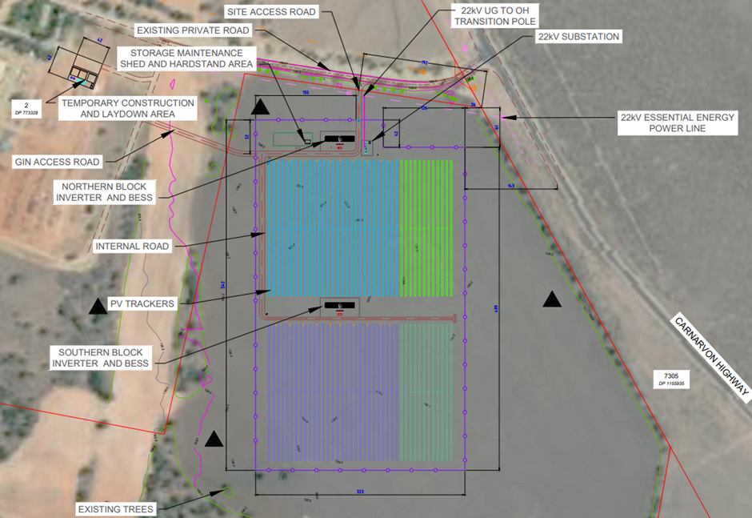

**Figure 3 –** Plan of solar arrays, proposed and existing infrastructure including 22kV Essential energy power line (excerpt from Applicant’s SEE prepared by RPS APP 2023)

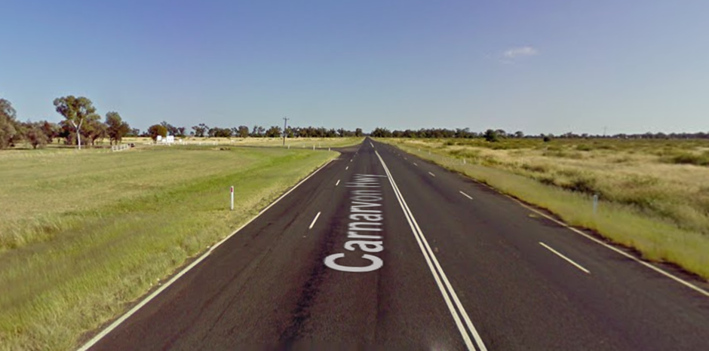

**Figure 4 -** View looking north, entry to site (on left) with slip lane. (Google Maps)

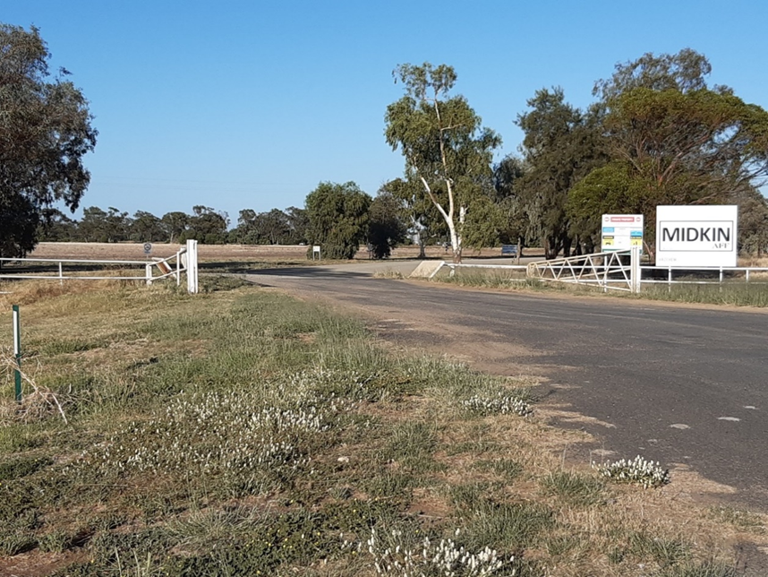

**Figure 5 -** View of entry to the site from Carnarvon Hwy (Google Maps)

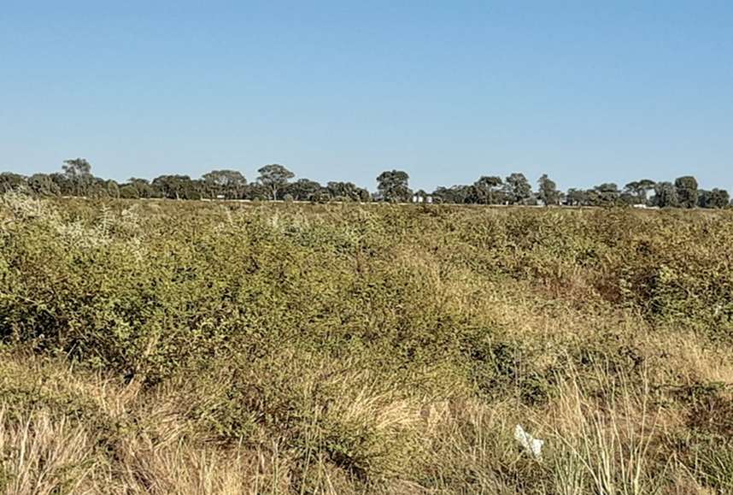

**Figure 6 –** View from Carnarvon Hwy looking North West towards site.

* 1. **Background**

The development application was lodged on 12 January 2023. A chronology of the development application since lodgement is outlined below including the Panel’s involvement (briefings, deferrals etc) with the application:

**Table 2: Chronology of the DA**

| **Date** | **Event** |
| --- | --- |
| 12 January 2023 | DA lodged |
| 3 February 2023 | 28 Day notification period of the proposal closing 3 March 2023. (No submissions were received) |
| 3 February 2023 | DA referred to external agencies |
| 11 April 2023 | Request for Information (RFI) from Council to applicant |
| 12 April 2023 | Applicant responded to RFI. |
| 24 May 2023 | Northern Regional Panel Briefing |

* 1. **Site History**

The site where the solar farm is to be located has no previous development history. The land most recently being used for cropping, a barley crop being the most recent use in 2022.

1. **STATUTORY CONSIDERATIONS**

When determining a development application, the consent authority must take into consideration the matters outlined in Section 4.15(1) of the *Environmental Planning and Assessment Act 1979* (‘EPA Act’). These matters as are of relevance to the development application include the following:

1. *the provisions of any environmental planning instrument, proposed instrument, development control plan, planning agreement and the regulations*

*(i)  any environmental planning instrument, and*

*(ii)  any proposed instrument that is or has been the subject of public consultation under this Act and that has been notified to the consent authority (unless the Planning Secretary has notified the consent authority that the making of the proposed instrument has been deferred indefinitely or has not been approved), and*

*(iii)  any development control plan, and*

*(iiia)  any planning agreement that has been entered into under section 7.4, or any draft planning agreement that a developer has offered to enter into under section 7.4, and*

*(iv)  the regulations (to the extent that they prescribe matters for the purposes of this paragraph),*

*that apply to the land to which the development application relates,*

1. *the likely impacts of that development, including environmental impacts on both the natural and built environments, and social and economic impacts in the locality,*
2. *the suitability of the site for the development,*
3. *any submissions made in accordance with this Act or the regulations,*
4. *the public interest.*

These matters are further considered below.

It is noted that the proposal is not considered to be:

* Integrated Development (s4.46); or
* Designated Development (s4.10).
  1. **Environmental Planning Instruments, proposed instrument, development control plan, planning agreement and the regulations**

The relevant environmental planning instruments, proposed instruments, development control plans, planning agreements and the matters for consideration under the *Environmental Planning and Assessment Regulation 2021* (EPA Regulation) are considered below.

1. **Section 4.15(1)(a)(i) - Provisions of Environmental Planning Instruments**

The following Environmental Planning Instruments are relevant to this application:

* [*State Environmental Planning Policy (Biodiversity and Conservation) 2021*](https://legislation.nsw.gov.au/view/html/inforce/current/epi-2021-0722)
* [*State Environmental Planning Policy (Planning Systems) 2021*](https://legislation.nsw.gov.au/view/html/inforce/current/epi-2021-0724)
* [*State Environmental Planning Policy (Primary Production) 2021*](https://legislation.nsw.gov.au/view/html/inforce/current/epi-2021-0729)
* [*State Environmental Planning Policy (Resilience and Hazards) 2021*](https://legislation.nsw.gov.au/view/html/inforce/current/epi-2021-0730)
* [*State Environmental Planning Policy (Transport and Infrastructure) 2021*](https://legislation.nsw.gov.au/view/html/inforce/current/epi-2021-0732)
* *Moree Plains Local Environmental Plan 2011.*

The key matters for consideration arising from these State Environmental Planning Policies are summarised in **Table 3** and considered in more detail below.

**Table 3: Summary of Applicable Environmental Planning Instruments**

| **EPI** | **Matters for Consideration** | **Comply (Y/N)** |
| --- | --- | --- |
| State Environmental Planning Policy (Biodiversity & Conservation) 2021 | Chapter 2: Vegetation in non-rural areas  Impact of Development  Chapter 3: Koala Habitat Protection 2020  Impact of the development on fauna and habitat  Chapter 4: Koala Habitat Protection 2021  Impact of the development on fauna and habitat | Yes – no significant impact  Yes – No significant impact  Yes - No significant impact |
| State Environmental Planning Policy (Planning Systems) 2021 | Chapter 2: State and Regional Development  Whether development is State or Regionally significant | Yes |
| State Environmental Planning Policy (Primary Production) 2021 | Chapter 2: Primary Production and rural development  Developments consistency with aims/objectives of the policy. Sustainability of the development. | Yes |
| SEPP (Resilience & Hazards) 2021 | Chapter 4: Remediation of Land  Previous use of the land and its suitability for the current proposal. | Yes |
| State Environmental Planning Policy (Transport and Infrastructure) 2021 | Chapter 2: Infrastructure  Part 2(3) Development Controls:-  Definition of development  Permissibility  Effect on electricity network  Effect on Roads and traffic | Yes |
| Proposed Instruments | No compliance issues identified. | N/A |
| Moree Plains Local Environmental Plan 2011 (LEP) | Part 2 - Permissibility and zone objectives  The development is defined as ‘electricity generating works’ and is neither specifically listed under schedule 3 as ‘Permitted with consent’, nor listed in schedule 4 – as ‘Prohibited’. The use is therefore included as ‘Any other development not specified in item 2 or 4’ which is found at the end of the list of uses in Schedule 3 – ‘Permitted with consent’ pursuant to the LEP land use table.  It is considered that the proposed construction of a 4.99MW solar farm is consistent with the objectives of the land use zone for the following reasons: -   * The proposal will encourage sustainable primary industry by providing renewable energy to the Midkin Cotton Gin, an essential part of the cotton growing industry; * Diversity of primary industry is encouraged by the new activity ‘generation of electricity’ which could be classified as ancillary to the existing cotton gin; * The area to be used is limited to only 14.5ha and is situated between the Carnarvon Highway and the Gin. In addition, the use could be removed in the future, so permanent alienation of land for other uses would not occur in the longer term; * The solar farm is suitably located close to the end user of the electricity (Midkin Gin) and Essential Energy 22kV infrastructure, so excess power can be routed to the state grid; * The provision of independent, reliable energy to the Gin will help protect the longer-term viability/sustainability of cotton growing in the area; * The use of 14.5ha of farmland for the solar farm will not unduly impact the rural character of the area.   Part 4 - Principal Development Standards  None Applicable  Part 5 - Miscellaneous provisions  Clause 5.10 – Heritage Conservation  The proposed development is in the vicinity of a Heritage Item, the “Midkin” Homestead (Item No. I004) which is situated on the adjoining Lot 35, DP 751775.  The proposed solar panels and plant will be approximately 1.5-2km from the Midkin Homestead, so the proposed development will have little visual or other impact on the heritage item and its curtilage due to the distance and vegetation which exists between the two.  The site is not identified as or located near a known Aboriginal Place of Heritage Significance on the Aboriginal Cultural Significance map, or in the Moree Plains Aboriginal Heritage Study and therefore no Aboriginal Heritage Impact Assessment is required.  Clause 5.21 - Flood Planning  Cl 5.21(2) requires Council to consider developments and their impact on the land, riparian systems and other development. It is noted that the site is within the Gwydir Floodplain Management Zone C, which consists of land protected from alluvial flooding by flood protection works, including levees.  The applicant has provided a ‘Surface Water Assessment Report’ prepared by Northrop Consulting Engineers Pty Ltd, dated 16 December 2022, which has addressed the above issues.  Part 7 Additional Local Provisions  7.1 Earthworks  Before granting development consent for earthworks, the consent authority must consider the impact of works on the site and environs. In this regard no significant excavation is required or proposed, the minimal earthworks are limited to minor levelling, shallow excavation for slabs and footings and gravel for access roads.  Clause 7.7 - Places of Aboriginal Cultural Significance  The development is not located on land identified as “place of Aboriginal cultural significance” on the Aboriginal Cultural Significance Map Sheet ACS_004, included with the LEP. | Yes  Yes  Yes  Yes |
| Moree Plains Development Control Plan 2013 (DCP) | Chapter 2 – Parking  Construction Phase - An average 20 employees with a peak of 40 is anticipated. Ten (10) car spaces have been provided but there is ample parking in and around the temporary stockpile/laydown area and adjacent to the solar panel arrays on the proposed hardstand areas and gravel access roads.  The applicant has provided detailed information regarding HRV movements throughout the year and has programmed the construction phase to coincide with a period of reduced truck movements for gin operations, therefore, the combined HRV traffic for solar farm construction and ginning operations will be significantly less than that associated with the peak ginning season traffic.  Traffic Generation to the site, specifically trucks delivering infrastructure is also not determined to create any issues due to the timing of construction and direct access to the Carnarvon Highway.  Operational Phase - The solar farm once operational, will only require 1-2 sub-contractors to perform maintenance functions with the solar farm being largely autonomous.  Chapter 4 - Moree and Environs Floodplain Development and Management.  As mentioned in this report a ‘Surface Water Assessment Report’ prepared by Northrop Consulting Engineers Pty Ltd, dated 16 December 2022, has been provided with the application which satisfactorily addresses stormwater related issues.  Chapter 9 - Rural Development  Biodiversity - The site of the solar farm does not fall within land mapped as Koala habitat on the ‘Map of Potential Koala Habitat’ included in the DCP and as noted in Figure 1.14 in this report. Some areas of secondary Class B land can be found to the south-south west and further to the north west (albeit across the Carnarvon Hwy).  The proposal will not have any significant impact on flora and fauna particularly as approximately 450 trees and shrubs are proposed to be planted along the northwest and north of the site.  As the development is located on existing cropping land, no other impacts to biodiversity are expected.  Bushfire Management - The site of the proposed solar farm (not temporary storage area to the west) is classified as Vegetation Category 3.  However, the area to be utilised is cleared cropping land. Some remnant bushland exists to the southwest approximately 80-100m from the southwest corner of the solar arrays.  An Asset Protection Zone (APZ) greater than 10m will be easily achievable for the proposed development. However, a condition will be imposed to ensure this is maintained.  Further, it is considered the solar farm has been designed to minimise the impact of bush fires on the development and its risk to adjacent bush.  ‘A Bush Fire Emergency Management and Operations Plan’ will also be required by condition to identify all relevant risks and mitigation measures associated with the construction and operation of the solar farm.  Water Quality - As previously mentioned ‘Surface Water Assessment Report’ has been provided with the application which addresses water quality related issues.  The report’s summary that ‘*due to the small size of pollutant generating areas and the minor use of the facility by vehicles during operation, it is expected that the impact on water quality due to the facility will be insignificant*’ is concurred with.  Effects on Riparian areas  The report’s contention that the site ‘*does not contain, nor is it in close proximity, to any classified watercourses and as such riparian corridors are not impacted as part of the development*’ is also agreed with and raises no concerns in this issue  Transport Issues  As already addressed within this report, the 16-week construction period will attract the most vehicles to the site, but due to the number of vehicle trips expected at a quiet time for ginning operations and the direct access to the Carnarvon Highway (which has slip lanes into the Midkin Gin access road), no adverse traffic issues are expected.  Ample parking is available onsite for workers during the construction phase and during the operational phase with a maximum of 2 electrical subcontractors expected at any one time.  Chapter 10 - Notification Policy  The DA was publicly notified in accordance with Council policy for a period of 28 days commencing 3 February 2023 and closing 3 March 2023. The notification included letters to property owners/occupiers.  No submissions were received. | Yes |

|  |  |  |
| --- | --- | --- |
| **Large-Scale Solar Energy Guideline - 2022 - NSW DPI** | This Guideline has been developed for State Significant Development (**SSD**) which is not the case in the current development, however, the general assessment requirements include:-   * Landscape/visual impacts; * Agricultural land use; * Infrastructure contributions; * Waste management; * Decommissioning and rehabilitation; * Glint and glare; * Biodiversity; * Traffic/transport; * Water management; * Noise & vibration; * Air quality; * Social & economic impacts; * Hazards, and; * Heritage.   The above issues have generally been covered by the applicants SEE/consultants reports, and, this assessment. |  |

Consideration of the relevant SEPPs is outlined below:-

[***State Environmental Planning Policy (Biodiversity and Conservation) 2021***](https://legislation.nsw.gov.au/view/html/inforce/current/epi-2021-0722)

Chapter 2: Vegetation in non-rural areas

The proposed solar panels and infrastructure are located on a cleared paddock. However, two trees are located close to the south-west corner of the solar panel array which, although identified to be retained may require removal to provide an asset protection zone (APZ). It is not considered that these trees and other vegetation contain high biological value.

Chapter 3: Koala Habitat Protection 2020

The solar panel farm is not located in Primary or secondary class A or B habitat; however, some Secondary Class B land is located nearby. This potential habitat area will not be impacted by the proposal.

Chapter 4: Koala Habitat Protection 2021

No areas of natural vegetation that provide habitat will be affected.

***State Environmental Planning Policy (Planning Systems) 2021***

Chapter 2: State and Regional Development

The proposal is regionally significant development pursuant to Section 2.19(1) as it satisfies the criteria in Clause 5 of Schedule 6 of the Planning Systems SEPP. The proposed solar farm is defined as ‘electricity generating works’ which is ‘private infrastructure’ and has a CIV over $5 million ($7,081,815.00), and is therefore ‘regionally significant development’.

Accordingly, the Northern Regional Planning Panel is the consent authority for the application.

***State Environmental Planning Policy (Primary Production) 2021***

Chapter 2: Primary Production and rural development

Electricity generating works (‘solar energy systems’) are not specifically mentioned in the policy. However, the proposal is generally consistent with the broad aims of the policy as the area involved, 14.5ha, is not of significant size relative to surrounding agricultural land and will not permanently ‘sterilise’ rural land as it could revert to cropping land in the future, should the need arise.

Further, the generation of clean energy will contribute to sustainable agriculture in the area providing a reliable power source for the Midkin Cotton Gin, an essential part of the cotton growing industry of the region.

***SEPP (Resilience & Hazards) 2021***

The applicant has submitted a ‘SEPP Resilience and Hazards Assessment’ report by Advitech Pty Limited which reviews the proposal, current hazardous chemicals information, and design layouts, against the current SEPP’s for ‘Hazardous and Offensive Development’ requirements and other applicable legislation, regulations and guidelines.

Chapter 4: Remediation of Land

With regard to the remediation of land, the land has previously been used for cropping (and possibly grazing in the past) with no known uses that would be likely to have substantially contaminated the site. However, some residual herbicides and pesticides are likely in the soil from the recent cropping operations.

It is considered on the basis of the available information, the site is suitable for the solar farm use which will neither involve significant excavation, nor staff permanently on site - except during the construction phase. If a different, more intensive use is proposed in the future, a comprehensive site investigation may be required.

The proposal is considered to be consistent with the SEPP, subject to imposition of relevant conditions of consent in relation to remediation works during construction on any consent granted.

A condition may also be imposed regarding the decommissioning of the site to enable remediation of the site as required. This condition will be associated with a s.88B Positive Covenant for registration on the title of Lots 2 and 3 DP 773238.

***State Environmental Planning Policy (Transport and Infrastructure) 2021***

Chapter 2: Infrastructure

Part 2(3) Development Controls:-

Division 4 Electricity generating works or solar energy systems. The proposed development is defined as a :- ‘*solar energy system’*. Clause 2.36 further states that:-

Development permitted with consent:-

*‘(9) solar energy systems - Development for the purpose of a solar energy system may be carried out by any person with consent on any land.’*

The proposal is permitted with consent by the SEPP regardless of the Moree Plains LEP 2011.

Division 5 - Electricity transmission or distribution.

Subdivision 2 - Development likely to affect an electricity transmission or distribution network.

The proposed solar farm and infrastructure is within 10m of Essential Energy’s 22kV overhead power lines and as such, the electricity supply authority is to be consulted.

Essential Energy was advised of the proposal and comments have been noted above in this report.

Division 17 - Roads and traffic. Subdivision 2 - Development in or adjacent to road corridors and road reservations

2.122 Traffic-generating development

The proposed solar farm (‘*solar energy system’*) is not specifically defined in Schedule 3 of the SEPP as Traffic-generating development and as such would be classified as ‘Any other purpose’ which requires referral to TfNSW if it involves a development that generates ‘50 or more motor vehicles per hour’ in the case of it having ‘access to classified road or to road that connects to classified road (if access within 90m of connection, measured along alignment of connecting road)’.

The proposal, although not generating 50 or more motor vehicles per hourwas however referred to Transport for NSW and initial comments requested a Traffic Impact Assessment (TIA) to be submitted for consideration*.*

The applicant provided detailed counts of existing heavy vehicle movements associated with the Cotton Gin (as all trucks are required to be weighed on entry to calculate the raw material). The RHV (truck) movements fluctuate with the cotton harvest and the Solar Farm construction phase is to be programmed to coincide with a period of reduced activity.

The data provided suggests that truck movements associated with the gin activities and those associated with the Solar Farm construction will have a combined number considerably less than that of the peak of cotton ginning season.

**Moree Plains Local Environmental Plan 2011**

The relevant local environmental plan applying to the site is the *Moree Plains Local Environmental Plan 2011* (‘the LEP’). The aims of the LEP include:-

*(a) to encourage the management, development and conservation of environmental, economic and social resources,*

*(b) to facilitate economic growth and development that is consistent with the aim specified in paragraph (a) and that—*

*(i) embraces the principles of environmentally sustainable development, and*

*(ii) minimises the cost to the community of fragmented and isolated development, and*

*(iii) facilitates the efficient and effective delivery of amenities and services, and*

*(iv) facilitates stimulation of demand for a range of residential, enterprise and employment opportunities and promotes agricultural diversity, and*

*(v) facilitates farm adjustments, and*

*(vi) utilises, where feasible, existing infrastructure and roads for new development and future potential development,*

*(c) to facilitate development in accordance with flood management planning,*

*(d) to facilitate development that is compatible with adjoining and nearby uses,*

*(e) to facilitate development that is appropriate in scale and type to the characteristics of the relevant zone,*

*(f) to recognise places of European heritage significance and Aboriginal heritage and cultural significance.*

The proposal is consistent with these aims as the proposal seeks to provide an existing agricultural industry (cotton farming) with a sustainable energy source.

**Zoning & Permissibility**

The site is located within the RU1 Primary Production Zone pursuant to Clause 2.2 of the LEP.

The development is defined as ‘electricity generating works’ and is neither specifically listed under schedule 3 as ‘Permitted with consent’, nor listed in schedule 4 – as ‘Prohibited’. The use is therefore included as ‘Any other development not specified in item 2 or 4’ which is found at the end of the list of uses in Schedule 3 – ‘Permitted with consent’ pursuant to the LEP land use table.

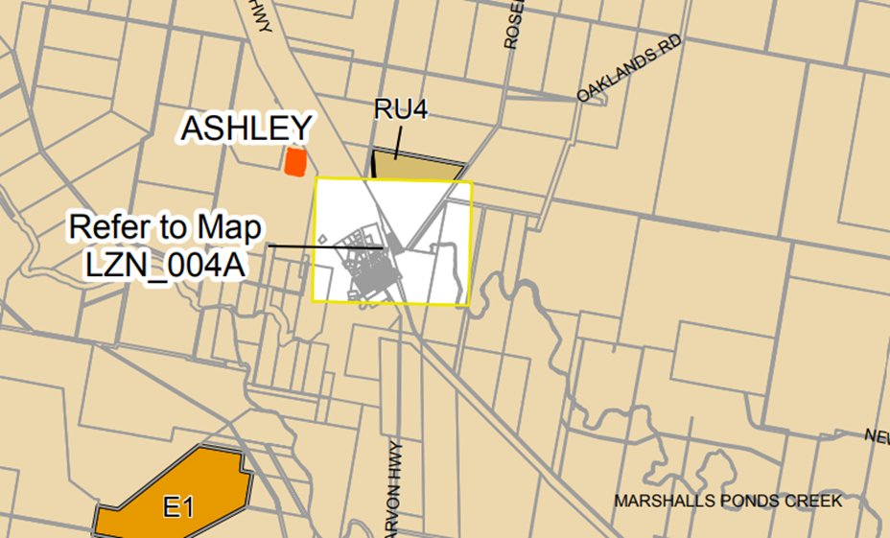

**Figure 7** - Land Use Zoning – location of site shaded orange northwest of Ashley township

State Environmental Planning Policy (Transport and Infrastructure) 2021, Chapter 2: Infrastructure, Part 2(3) Development Controls, Division 4, Clause 2.36 also further states that:-

Development permitted with consent:-

‘(9) solar energy systems - Development for the purpose of a solar energy system may be carried out by any person with consent on any land.’

The proposal is permitted with consent by the SEPP regardless of the Moree Plains LEP 2011.

The zone objectives include the following (pursuant to the Land Use Table in Clause 2.3):

* *To encourage sustainable primary industry production by maintaining and enhancing the natural resource base.*
* *To encourage diversity in primary industry enterprises and systems appropriate for the area.*
* *To minimise the fragmentation and alienation of resource lands.*
* *To minimise conflict between land uses within this zone and land uses within adjoining zones.*
* *To permit development for certain purposes if it can be demonstrated that suitable land or premises are not available elsewhere.*
* *To protect significant agricultural resources in recognition of their value to the longer term economic sustainability of Moree Plains.*
* *To maintain the rural character of the land.*

The proposal is considered to be consistent with these zone objectives for the following reasons:

* The proposal will encourage sustainable primary industry by providing renewable energy to the Midkin Cotton Gin, an essential part of the cotton growing industry;
* Diversity of primary industry is encouraged by the new activity ‘generation of electricity’ which could be classified as ancillary to the existing cotton gin;
* The area to be used is limited to only 14.5ha and is situated between the Carnarvon Highway and the Gin. In addition, the use could be removed in the future, so permanent alienation of land for other uses would not occur in the longer term;
* The solar farm is suitably located close to the end user of the electricity (Midkin Gin) and Essential Energy 22kV infrastructure, so excess power can be routed to the state grid;
* The provision of independent, reliable energy to the Gin will help protect the longer-term viability/sustainability of cotton growing in the area;
* The use of 14.5ha of farmland for the solar farm will not unduly impact the rural character of the area

*General Controls and Development Standards (Part 2, 4, 5 and 6)*

The LEP also contains controls relating to development standards, miscellaneous provisions and local provisions. The controls relevant to the proposal are considered in **Table 4** below.

**Table 4: Consideration of the LEP Controls**

| **Control** | **Requirement** | **Proposal** | **Comply** |
| --- | --- | --- | --- |
| Minimum subdivision Lot size  (Cl 4.1) | Min 650m2 | No subdivision proposed | N/A |
| Rural Subdivision  (Cl 4.2) | Min 650m2 | No subdivision currently proposed | N/A |
| Height of buildings  (Cl 4.3) | The development control has not been adopted |  | N/A |
| FSR  (Cl 4.4) | The development control has not been adopted. |  | N/A |
| Heritage  (Cl 5.10) | Consideration of impact of development in vicinity to Heritage Item and any impacts on Aboriginal Heritage. | The proposed development is in the vicinity of a Heritage Item, the “Midkin” Homestead (Item No. I004) which is situated on the adjoining Lot 35, DP 751775. The proposed solar panels and plant will be approximately 1.5-2km from the Midkin Homestead, so the proposed development will have little visual or other impact on the heritage item and its curtilage due to the distance and vegetation which exists between the two.  The site is not identified as or located near a known Aboriginal Place of Heritage Significance on the Aboriginal Cultural Significance map, or in the Moree Plains Aboriginal Heritage Study and therefore no Aboriginal Heritage Impact Assessment is required. | Yes |
| Flood planning (Cl 5.21) | Consideration of flood impacts on the development site, riparian systems, other properties and persons. | Cl 5.21(2) It is noted that the site is within the Gwydir Floodplain Management Zone C, which consists of land protected from alluvial flooding by flood protection works, including levees.  The applicant has provided a ‘Surface Water Assessment Report’ prepared by Northrop Consulting Engineers Pty Ltd, dated 16 December 2022, which has satisfactorily addressed the above issue. | Yes |
| Earthworks  (Cl 7.1) | Before granting development consent for earthworks, the consent authority must consider the impact of works on the site and environs. | In this regard no significant excavation is required or proposed, the minimal earthworks are limited to minor levelling, shallow excavation for slabs and footings and swales for the gravel for access roads. | Yes |
| Places of Aboriginal Cultural Significance  (Cl 7.7) | Consideration of impact of development on Aboriginal Heritage. | The development is not located on land identified as “place of Aboriginal cultural significance” on the Aboriginal Cultural Significance Map Sheet ACS_004, included with the LEP. | Yes – Condition can be imposed should any artifacts be discovered during construction. |

The proposal is considered to be generally consistent with the LEP.

1. **Section 4.15 (1)(a)(ii) - Provisions of any Proposed Instruments**

There are several proposed instruments which have been the subject of public consultation under the EPA Act, however most are not relevant to the current proposal, an exception is the:-

* ***Draft Remediation of Land SEPP***

This proposed instrument is considered below:

**Draft Remediation of Land SEPP**

NSW Planning states:-

*‘Currently SEPP 55 is being reviewed as part of the NSW Government’s broader review program that aims to ensure all State Environment Planning Policies, SEPPs, are up-to-date and relevant.*

*As well the current SEPP 55 and its associated Managing Contaminated Land Planning Guidelines have been in place for almost 20 years. Both need to be updated to respond to changes in federal and state legislation and policy, and to reflect new land remediation practices.’*

Most of the existing provisions of SEPP 55 and SEPP Resilience and Hazards are incorporated into the Draft SEPP.

The subject site does not require remediation for the proposed use however attention will still be required during the decommissioning of the farm to ensure the BESS plant is disposed of without contaminating the site.

The proposal is generally consistent with the proposed instrument.

1. **Section 4.15(1)(a)(iii) - Provisions of any Development Control Plan**

The following Development Control Plan is relevant to this application:

* *Moree Plains Development Control Plan 2013* (‘the DCP’)

Chapter 2 – Parking

Construction Phase - An average 20 employees with a peak of 40 is anticipated. Ten car spaces have been provided, but there is ample parking in and around the temporary stockpile/laydown area and adjacent to the solar panel arrays on the proposed hardstand areas and gravel access roads.

Traffic Generation to the site, specifically trucks delivering infrastructure is also not determined to create any issues due to the timing of construction and direct access to the Carnarvon Highway.

Operational Phase - The solar farm once operational, will only require 1-2 sub-contractors to perform maintenance functions with the solar farm being largely autonomous.

Transport for NSW has commented on the proposal on 2 June 2023 and made the following comments:-

*‘TfNSW has reviewed the information and has no objections in response to the proposed development, upon further review, TfNSW does not have a legislative role as a part of this development application.*

*Notwithstanding the above, TfNSW provides the following comments to assist with the assessment of the development application:*

*1. Consider the development of a Traffic Management Plan and Code of Conduct, to provide traffic mitigation measures to address the cumulative traffic impacts, during the peak of the construction of the development and the cotton ginning season for the existing Midkin Cotton Gin.*

A condition of development consent is recommended in this regard.

Chapter 4 - Moree and Environs Floodplain Development and Management.

As mentioned in this report a ‘Surface Water Assessment Report’ prepared by Northrop Consulting Engineers Pty Ltd, dated 16 December 2022, has been provided with the application which satisfactorily addresses stormwater related issues.

Chapter 9 - Rural Development

Biodiversity - The site of the solar farm does not fall within land mapped as Koala habitat on the ‘Map of Potential Koala Habitat’ included in the DCP and as noted in **Attachment I** in this report, although, some areas of secondary Class B land can be found to the south-south west and further to the north west (albeit across the Carnarvon Hwy).

As mentioned, two trees may require removal, however this should not have any significant impact of the flora and fauna when approximately 450 trees and shrubs are proposed to be planted along the northwest and north of the site.

As the development is located on existing cropping land, no other impacts to biodiversity are expected.

Bushfire Management - The site of the proposed solar farm (not temporary storage area to the west) is classified as Vegetation Category 3. However, the area to be utilised is cleared cropping land. Some remnant bushland exists to the southwest approximately 80-100m from the southwest corner of the solar arrays.

An Asset Protection Zone (APZ) greater than 10m will be easily achievable for the proposed development. However, a condition will be imposed to ensure this is maintained. Further, it is considered the solar farm has been designed to minimise the impact of bush fires on the development and its risk to adjacent bush.

‘A Bush Fire Emergency Management and Operations Plan’ will also be required by condition to identify all relevant risks and mitigation measures associated with the construction and operation of the solar farm.

Water Quality - As previously mentioned a ‘Surface Water Assessment Report’ has been provided with the application which addresses water quality related issues.

The report’s summary that ‘due to the small size of pollutant generating areas and the minor use of the facility by vehicles during operation, it is expected that the impact on water quality due to the facility will be insignificant’ is concurred with.

Effects on Riparian areas - The report’s contention that the site ‘does not contain, nor is it in close proximity, to any classified watercourses and as such riparian corridors are not impacted as part of the development’ is also agreed with and the proposal raises no concerns in this regard.

Transport Issues - As already addressed within this report, the 16-week construction period will attract the most vehicles to the site, but due to the number of vehicle trips expected and the direct access to the Carnarvon Highway (which has slip lanes into the Midkin Gin access road), no adverse traffic issues are expected.

Ample parking is available onsite for workers during the construction phase and during the operational phase with a maximum of 2 electrical subcontractors expected at any one time.

Chapter 10 - Notification Policy

The DA was publicly notified in accordance with Council policy for a period of 28 days commencing 3 February 2023 and closing 3 March 2023. The notification included letters to property owners/occupiers. No submissions were received.

The following contributions plans are relevant pursuant to Section 7.18 of the EPA Act and have been considered in the recommended conditions (notwithstanding Contributions plans are not DCPs they are required to be considered):

*S7.12 Development Contributions Policy*

MPSC has adopted a contribution for development with a ‘value greater than $200,000 being 1.0% of the value’.

The proposed solar farm has a CIV of $7,081,815.00, therefore 1% of that figure is $70,818.15.

This Contributions Policy has been considered and included in the recommended draft consent conditions.

1. **Section 4.15(1)(a)(iiia) – Planning agreements under Section 7.4 of the EP&A Act**

There have been no planning agreements entered into and there are no draft planning agreements being proposed for the site.

1. **Section 4.15(1)(a)(iv) - Provisions of Regulations**

Section 61 of the EPA Regulation contains matters that must be taken into consideration by a consent authority in determining a development application, with the following matters being relevant to the proposal:

* The proposal is able to satisfy either the deemed-to-satisfy provisions and/or the performance requirements of the National Construction Code (NCC).

Section 62 (consideration of fire safety) and Section 64 (consent authority may require upgrade of existing buildings) of the EPA Regulation are not relevant to the proposal.

These provisions of the EPA Regulation have been considered and are addressed in the recommended draft conditions (where necessary).

* 1. **Section 4.15(1)(b) - Likely Impacts of Development**

The likely impacts of that development, including environmental impacts on both the natural and built environments, and social and economic impacts in the locality must be considered. In this regard, potential impacts related to the proposal have been considered in response to SEPPs, LEP and DCP controls outlined above and the Key Issues section below.

The consideration of impacts on the natural and built environments includes the following:

* Context and setting – The proposal is considered to be generally consistent with the context of the site, in that the proposed solar farm is ancillary to the existing cotton gin and will provide reliable, sustainable energy to the facility. In a regional context, solar farms are an increasing feature in rural NSW as Local Government bodies and private enterprise (as is the case of the Midkin Gin) move to self-sufficiency for electricity needs.

The site is level as a result of the prevailing topography and its former use for cropping, so the solar panel arrays (with a maximum, operational height of 4.2m), BESS modules and maintenance shed no more than 2.9m in height, should not impact the scenic qualities of the area as existing vegetation and landscape screening is proposed to obscure the development from the Carnarvon Highway.

“Midkin” Homestead (Item No. I004) an item of local environmental heritage is located 1.5-2km to the south west of the proposed solar farm however the flat nature of the area and intervening vegetation would result in little impact on the visual character of the item.

* Access and traffic – Access to the site is achieved from the existing private access road between the Midkin Cotton Gin and Carnarvon Highway. A slip lane exists for traffic travelling north from Moree and Ashley. The construction of the proposed development is programmed for a period of 18/19 weeks, although the majority of construction activity is forecast for a 4/5 week period within this overall construction phase.
* The development is scheduled during a period of reduced activity at the Midkin Gin so that heavy vehicles associated with construction, in addition to ginning activities would not exceed the level of heavy vehicle traffic expected during the peak ginning season. Average deliveries across the construction period are roughly 20 deliveries a week. (see Attachment J).

The SEE estimates a construction workforce of up to 40 employees at the peak of construction, with an average workforce around 20 full-time employees over the course of 12-16 weeks.

Once completed the Solar Farm will be largely autonomous with only 1/2 contractors tasked with ongoing maintenance.

Ten dedicated car parking spaces are proposed, but ample informal parking space is available to cater for fluctuations in workers during the construction phase.

It is considered that traffic associated with the construction of the solar farm and ongoing operation will not create any excessive adverse impacts on the site and surrounding road network.

TfNSW has provided an updated comment on the proposal (dated 2nd June 2023), and states it has no objection to the development. The response did however suggest consideration be given to requiring a Traffic Management Plan and Code of Conduct to mitigate any traffic issues which might arise during the construction phase. A condition is recommended in this respect.

* Public Domain – The public domain, being the Carnarvon Highway will not be unduly impacted by the solar farm as the flat topography, and landscape screening will largely obscure the panel arrays and associated structures (BESS system and maintenance shed) only achieve heights of no more than 4.2m for the solar panels and 2.9m for the maintenance shed.
* Utilities – An ‘Essential Energy’ 22kV power line is located to the north of the site, and, connection to the grid will be required for the construction phase. Following commissioning the Solar Farm will be able to provide for the electricity needs of the Midkin Gin and also surplus current to the State grid. Town water is not available to the site however two water tanks are included in the temporary construction and laydown area for the workers and construction purposes.
* Heritage – The ‘Midkin Homestead’ an item of local environmental heritage is located on an adjoining lot just over 1.5km to the southwest of the proposed solar farm. Considering the distance, modest height of the proposed panel arrays and intervening vegetation it is not considered the development will adversely impact the heritage item or its setting.
* No recorded Aboriginal sites or places of cultural significance are recorded in or within a 200m radius of the proposed solar farm or temporary construction stockpile area, however, suitable protocols can be conditioned if any unexpected finds occur during construction.
* Other land resources – The solar farm is unlikely to have any impact on the local water catchment as few hard surface areas are proposed, and, the flat nature of the site results in no concentrated flow paths being identified. The surrounding irrigation channels appear to collect most of the concentrated flow in and around the site with the minor runoff from the solar panels and gravel access road being catered for by roadside swales.
* The farm will remove approximately 14.5ha of land from direct agricultural use, which is a relatively small area in this region. The solar farm could be considered ancillary to the Cotton Gin as it will provide renewable energy for this facility. Should the need arise, the solar panel arrays and plant could be removed in the future and the land reverted to cropping.
* Water/air/soils impacts – The solar farm would not contaminate the surroundings in the normal operation of the facility, with the only possible scenario being a chemical leakage from a fire in the BESS plant. The RFS has been consulted and appropriate conditions recommended to mitigate this unlikely event.
* Flora and fauna impacts – As the facility is located on existing, cleared cropping land with little impact on vegetation. The report provided by the applicant prepared by Northrop Consulting indicates little impact on water quality and with the site being located outside primary and secondary Koala habitat zones (Attachment 1) the proposal will result in insignificant impacts in that regard.
* No other species of flora or fauna are expected to be impacted. The solar farm is to be secured with 2.25m chain link and barbed wire fencing which would generally prevent most wildlife entering the facility.

* Natural environment – No significant changes are proposed to the natural contours of the site which is characterised by a flat topography.
* Noise and vibration:–

*Construction Phase* - The SEE report acknowledges that during construction, the use of a compactor or front end loader (the loudest rated items of machinery to be used) may exceed 5db standard over background noise in the closest ‘receptor’ (Ashley township 1.7km distant). The applicant claims that use of this plant will be limited and ‘*will not cause a permanent lasting effect on the acoustic amenity of the local area*’.

*Operational phase* – The continuing operation of the panels, Bess system and plant are expected to create sound levels of only 15db to Ashley township and as the rated baseline background noise levels have been calculated at 35dB during daytime (7am-6pm), and 30dB during evening and night (6pm-7am) the operation of the solar farm is not expected to cause an impact in this regard.

* Glint and Glare:- Whilst solar panels are specifically designed to absorb sunlight and not reflect it, (reflecting less than 2% as a general rule) glint and glare can on occasion present issues to adjoining land. In this regard the proposed solar panel arrays are:-
* More than 5km from Moree airport;
* Located on flat land;
* Generally obscured from view from the Carnavon Hwy, Midkin Homestead and the more distant Ashley village by existing and proposed vegetation.

The panels are capable of realignment should the unlikely event of glint/glare become an issue. As noted in the Statement of Environmental Effects ‘*The proposed solar PV panels are to be mounted on solar trackers which results in minimal potential for horizontal reflectivity to occur as light is generally reflected upwards*.’.  In addition to this the Carnarvon Highway (most likely receptor) would be screened by landscaping along the north and eastern sides of the solar farm.

* Natural hazards –

*Flooding* - It is noted that the site is within the Gwydir Floodplain Management Zone C, which consists of land protected from alluvial flooding by flood protection works, including levees. The applicant has provided a ‘*Surface Water Assessment Report’* prepared by Northrop Consulting Engineers who have claimed that the development

‘…will result in minimal restriction to overland flow paths and impacts upstream / downstream of the Site.’ This view is concurred by Council Officers.

*Bushfire* – The development has been referred to the RFS who has made a number of recommendations including the provision of a defendable Asset Protection Zone (APZ) and a 20,000lt water tank. It is considered this potential hazard has been adequately addressed by the proposal.

* Safety, security and crime prevention – A chain-link security fence is proposed to be provided to the site’s perimeter, being 1.8m in height with 3 rows of barbed wire affixed on top for a total height of 2.25m. The fence will be fixed by engineered embedded concrete foundations. A CCTV system could easily be installed at a later date should the need arise.
* Social impact – No social impacts are expected to occur as a result of the solar farm development. The relatively short duration of the construction phase and minimal requirement for staff in the ongoing operation of the facility will create no long term housing issues.

With regard to community safety, a catastrophic failure of the Bess system would appear the only scenario that could affect the wider community. The RFS has recommended conditions which would mitigate this unlikely scenario.

* Economic impact – The construction phase of the development, may generate some temporary local employment however this phase is relatively short lived at between 4 and five months. The SEE states that 1-2 local subcontractors will likely be employed for ‘general care and maintenance of the site’ as the facility is generally autonomous.

The main economic benefit to the local communities of Ashley and Moree are likely to result during the construction phase from patronage of accommodation, food and retail establishments.

* Site design and internal design – The development is located close to the Midikin Cotton Gin and Essential Energy infrastructure, furthermore, the proposal is within close proximity to the Carnarvon Highway should emergency services be required.
* Construction – The proposal is located approximately 2 km from Ashley village. This separation would mitigate any minor noise impacts. Sediment control measures have been included on the development plans.
* Cumulative impacts – It is not considered the proposal will result in any adverse cumulative impacts. Construction has been programmed for the period of reduced cotton ginning at the Midkin Gin and once complete the facility will be largely autonomous.

Accordingly, it is not considered that the proposal will result in any significant adverse impacts in the locality as outlined above.

* 1. **Section 4.15(1)(c) - Suitability of the site**

It is considered the proposal is well suited to the site and locality as it is situated between existing Essential Energy infrastructure and the Midkin Cotton Gin. The site is adjacent to the Carnarvon Highway and is a sufficient distance from the village of Ashley as to not constitute undue noise impacts during construction, and certainly not during operation.

Proximity to the cotton gin also provides a level of passive surveillance during much of the year although the facility will be fenced off and secured.

The site is approximately 20km to Moree or less than a 20min drive which is a reasonable distance for workers during the construction phase and also maintenance technicians to attend the site during ongoing operation of the solar farm.

The facility is to be sited on cleared, level ground (formerly cropping land) and so only minor earthworks are proposed to prepare the site for its intended use. Flooding and bushfire hazards are relatively minor and have been addressed in the applicant’s consultant reports and in the recommended draft conditions.

There are no adjoining land uses which would impact the proposal and the proposed development would not impact the adjoining agricultural land to any significant degree.

* 1. **Section 4.15(1)(d) - Public Submissions**

No submissions were received in response to public notification of the application.

* 1. **Section 4.15(1)(e) - Public interest**

It is considered the proposal for a solar farm is in the public interest as:-

* The proposal will provide renewable energy to cater for the needs of the Midkin Cotton Gin (a facility that processes cotton for local cotton growers);
* The proposal will provide renewable surplus energy to the State grid, which will reduce the requirement for reliance on existing fossil fuel fired power stations and is therefore in the wider public interest;
* The proposal is consistent with planning controls of the Moree Plains LEP and DCP;
* The proposal will not have any adverse environmental impacts in the normal course of operations;
* The proposal is a sufficient distance from the nearest settlement that if a fire occurred at the BESS plant impacts could be mitigated;
* The proposal will provide some economic benefit to the local community during the construction phase and up to two permanent local jobs during operation;
* As mentioned, the development will provide additional capacity to the State grid via transfer of surplus electricity production which is consistent with the principles of ecologically sustainable development and mitigating climate change.

In view of the above, on balance, it is considered that the proposal is consistent with the local and wider public interest.

1. **REFERRALS AND SUBMISSIONS** 
   1. **Agency Referrals and Concurrence**

The development application has been referred to various agencies for comment/concurrence/referral as required by the EPA Act and outlined below in **Table 5**.

There are no outstanding issues arising from these concurrence and referral requirements subject to the imposition of the recommended conditions of consent being imposed.

**Table 5: Concurrence and Referrals to agencies**

| **Agency** | **Concurrence/**  **referral trigger** | **Comments**  **(Issue, resolution, conditions)** | **Resolved** |
| --- | --- | --- | --- |
| Concurrence Requirements (s4.13 of EP&A Act) | | | |
| N/A |  |  | N/A |
| Referral/Consultation Agencies | | | |
| RFS | S4.14 – EP&A Act  Development on bushfire prone land | On 14 February 2023, the NSW Rural Fire Service responded to Council’s referral.  No objection was raised to the development however a number of conditions were provided to be included as conditions of any consent.  The applicants request to delete the 20,000 litre water tank has not been supported by RFS. | Yes |
| Electricity supply authority | Section 2.48 – *State Environmental Planning Policy (Transport and Infrastructure) 2021*  Development near electrical infrastructure | On 20 February 2023, Essential Energy commented on the proposal and had no objections to the development subject to general recommendations which could be included as conditions in any consent granted. | Yes |
| Transport for NSW | Section 2.121 – *State Environmental Planning Policy (Transport and Infrastructure) 2021).* | Whilst the proposal is not deemed ‘Traffic Generating development’ the proposal was referred to TfNSW for comment. After initial comments by TfNSW were received on 13 March 2023, a follow up letter was received on 2 June 2023 stating:-  ‘TfNSW has reviewed the information and has no objections in response to the proposed development, upon further review, TfNSW does not have a legislative role as a part of this development application.’ Nevertheless, TfNSW did suggest that a TMP/Code of Conduct to be prepared for the development. | Yes |
| Integrated Development (S 4.46 of the EP&A Act) | | | |
|  |  |  | N/A |

* 1. **Council Officer Referrals**

The development application has been referred to various Council officers for technical review as outlined **Table 6.**

**Table 6: Consideration of Council Referrals**

|  |  |  |
| --- | --- | --- |
| **Officer** | **Comments** | **Resolved** |
| Engineering | No objections raised. Standard conditions to be applied | Yes |
| Traffic | No objections raised | Yes |
| Building | No objections raised. Standard conditions to be applied | Yes |
| Health | No objections raised | Yes |
| Waste | No objections raised | Yes |
| Public Domain/  Assets | N/A |  |
| Heritage | Council’s Heritage Officer/Consultant raised no objection to the proposal due to the distance and vegetation between the solar farm and the ‘Midkin Homestead’, an item of Local Environmental Heritage.  With regards to Aboriginal Heritage, the site is not identified as or located near a known Aboriginal Place of Heritage Significance on the Aboriginal Cultural Significance map, or in the Moree Plains Aboriginal Heritage Study and therefore no concerns are raised in this regard.  However, a condition could be imposed on any consent should any artifacts be discovered during the construction phase. | Yes |

* 1. **Community Consultation**

The proposal was notified in accordance with the Council’s Notification Policy from 3 February 2023 until 3 March 2023.

The notification included the following:

* An advertisement in the local newspaper Moree Champion
* Notification letters sent to adjoining and adjacent properties; (23letters issued);
* Notification on the Council’s website.

The Council received no submissions regarding the proposal.

**Table 7: Community Submissions**

| **Issue** | **No of submissions** | **Council Comments** |
| --- | --- | --- |
| N/A | Nil | N/A |

1. **KEY ISSUES**

**NORTHERN REGIONAL PLANNING PANEL – Briefing - 24 May 2023**

The briefing report to the panel raised the issues of:-

• Traffic

• Permissibility

• Environmental impact.

In relation to the above TfNSW has commented that they have no objection to the proposal on Traffic grounds.

With regards to permissibility the proposal is permissible on the basis that it is *‘Any other development not specified in item 2 or 4’ which is found at the end of the list of uses in Schedule 3 – ‘Permitted with consent’ pursuant to the LEP Land Use Table. Accordingly, the proposal is permitted with consent in the RU1 Primary Production zone under the LEP.*

In addition to the above, clause 2.36(9) of *State Environmental Planning Policy Transport and Infrastructure) 2021* (SEPP Transport and Infrastructure) states that ‘development for the purpose of a solar energy system may be carried out by any person with consent on any land.’

In relation to environmental impacts, these were considered minor and capable of being mitigated with appropriate conditions.

Following consideration of the ‘Briefing Report’ and discussion, the following issues were raised as being ‘Key Issues’ in the ‘Record of Briefing’ produced at the Northern Regional Planning Panels meeting. Comments will be applied to each issue to show how each has been resolved.

The following key issues are relevant to the assessment of this application having considered the relevant planning controls and the proposal in detail:

KEY ISSUES

* *‘****Existing site characteristics and infrastructure outlined’*** –

Resolution: A review of the site and infrastructure was made with no significant problems highlighted.

* ***‘Proposed development detailed, including access and supplementary planting’***

Resolution: The Concept Landscape Plan submitted with the application indicates landscaping along the north east (Carnarvon Hwy) side of the proposal in addition to the northern boundary.

* ***‘Confirmed the application for the 4.99MW facility encompasses both Stage One and Two arrays and Battery systems although the construction will be staged’***.

Resolution:- The installation of the solar arrays and Bess system will be in two ‘stages,’ however, the development application is for both stages. A condition is recommended to ensure each construction phase does not coincide with peak ginning season to mitigate possible traffic conflicts.

* ***‘Traffic – cumulative traffic report requested by TfNSW, additional information provided noting traffic generation and construction to occur during timeframe when cotton gin is less operational***.’

Resolution:- Following additional information provided by the applicant of existing Heavy vehicle movements to the site and projected movements, TfNSW provided a final letter dated 2 June 2023 stating that:-

‘*TfNSW has reviewed the information and has no objections in response to the proposed development, upon further review, TfNSW does not have a legislative role as a part of this development application.’*

A further Traffic Impact Assessment (TIA) is therefore not required, however it was suggested that a Traffic Management Plan and Code of Conduct could be prepared to mitigate any potential traffic issues between the operations of the Midkin Gin and the construction phases of the Solar Farm.

* ***‘Awaiting response from TfNSW.’***

Resolution:- As above.

* ***‘Battery storage and potential fire risk – RFS conditions have been provided***.’

Resolution:- The RFS has provided conditions to mitigate potential adverse impacts, which includes the provision of an APZ and a 20,000ltr water tank. The applicant requested reconsideration of the provision of the tank. However, as of the date of this report, the RFS has not agreed to its deletion, so the condition is still applicable.

* ***‘Supplementary plantings to be provided to minimise any visual impact from the highway’.***

Resolution:- The Landscaping plans provided by the applicant indicate landscape screening along the northern boundary of the site, and also along the north east boundary adjacent to the Carnarvon Highway.

* ***‘Rehabilitation and decommissioning strategy to be outlined in the assessment report and including timeframe***.’

Resolution:- The Draft Conditions for Solar Farms contains a standard relating to this issue which would be imposed on any consent granted in this regard.

* ***‘Retention of existing koala feed trees to the south’***

Resolution:- The existing stand of trees to the south-south west of the site is outside of the area of solar panels and can be retained. The two trees located in proximity to the south-west corner of the solar farm, whilst intended to be retained may require removal to provide for the required asset protection zone (APZ). As those two trees are relatively exposed and isolated from the main strand of trees their removal is unlikely to have any significant impact on koala habitat.

* ***‘Flooding – Surface Water Assessment submitted with application’***

Resolution:- The report prepared by Northrop Consulting Engineers Pty Ltd, dated 16 December 2022, Revision A, has considered the proposal’s impact on runoff, riparian corridors, surface water, flooding and erosion and sediment control. It is considered the application has adequately addressed these issues.

* ***‘Noted the Department of Planning has previously issued draft standard conditions for solar farms’***

Resolution:- The Draft conditions for Solar farms will be used as a basis for any draft consent conditions with the current application.

1. **CONCLUSION**

This development application has been considered in accordance with the requirements of the EPA Act and the EPA Regulation as outlined in this report. Following a thorough assessment of the relevant planning controls and the key issues identified in this report, it is considered that the application can be supported.

The key issues for the development are:-

* Managing the hazard of fire associated with the BESS system;
* Ensuring the development is decommissioned in a safe fashion at its ‘end of life’ to prevent contamination by chemicals from the BESS system;
* Ensuring no traffic impacts arise as a result of the construction phases of the development;
* Ensuring adequate landscape screening of the development is undertaken and that nearby Koala feed trees are preserved.

It is considered that the proposed solar farm, located adjacent to the Midkin Cotton Gin and existing Essential Energy infrastructure, will provide renewable energy to both these customers and as such, in the absence of any significant constraints, the proposal is suitable for the site and compatible with the locality.

It is considered that the key issues as outlined in Section 6 have been resolved satisfactorily through amendments to the proposal and/or in the recommended draft conditions at **Attachment A**.

1. **RECOMMENDATION**

That Development Application DA No. 2023/6 for construction of a 4.99MW solar farm and associated plant, fencing and landscaping at Lot Nos. 2 and 3 DP 773238 Nos. 1957 and 2761 Carnarvon Highway, Ashley (also known as 338 Windmill Road, Garah) be APPROVED pursuant to Section 4.16(1)(a) of the *Environmental Planning and Assessment Act 1979* subject to the draft conditions of consent attached to this report at **Attachment A**.

The following attachments are provided:

* Attachment A: Draft Conditions of consent;
* Attachment B: Design Drawings prepared by OGP Group;
* Attachment C: Landscape Drawing prepared by RPS Group Pty Ltd;
* Attachment D: Civil Engineering Drawings prepared by Northrop Consulting Engineers Pty Ltd;
* Attachment E: Statement of Environment Effects 22 December 2023 (as amended 17 April 2023) and prepared by RPS APP Consulting Pty Ltd;
* Attachment F: ‘SEPP Resilience and Hazards Assessment’ report prepared by Advitech Pty Limited dated 16 December 2022, and, in particular, its recommendation for a Preliminary Hazard Analysis (PHA) to be undertaken prior to any Redox flow batteries be installed;
* Attachment G: Surface Water Assessment Report’ prepared by Northrop Consulting Engineers Pty Ltd, dated 16 December 2022, Revision A;
* Attachment H: Applicants response to RFI including Appendix A & B dated 12 April 2023;
* Attachment I: ‘Map of Potential Koala Habitat’;
* Attachment J: Traffic Volumes Forecast Chart – Midkin Gin/Solar Farm;